MINRES to calculate vi – 2

So, I increased the accuracy of my implementation by setting tolerance to achieve as 1e-9, and performing 10,000 iterations - a slight bump from the previous 20.

Though I did notice the difference between 1000 and 10,000 iterations to not be really important.

My new window is 0 to 8, as recommended - MINRES is very good at calculating the vector corresponding to sigma = 0, and gets progressively worse.

Symmetric -

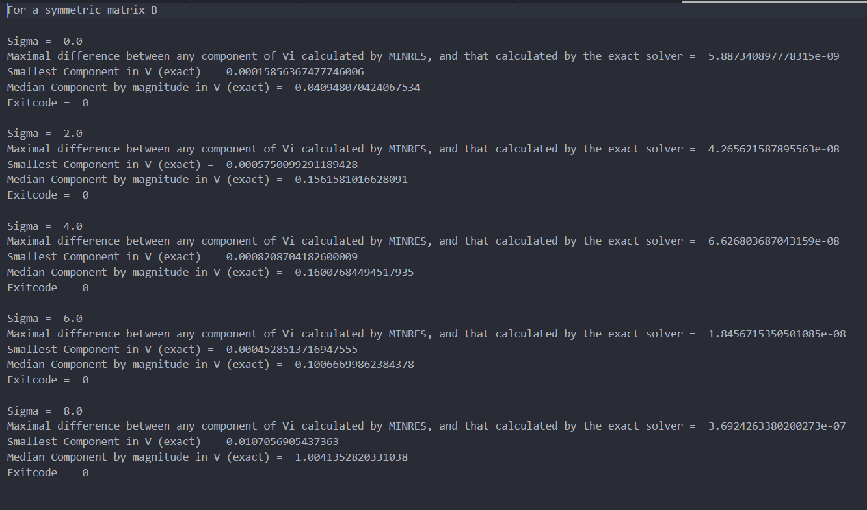

For an asymmetric matrix C = B + eta*del_B

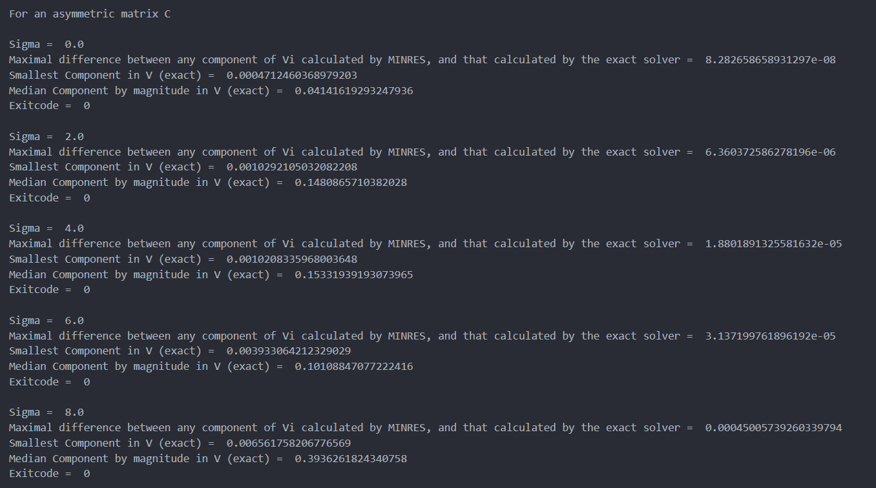

Concerning the eigenvalues –

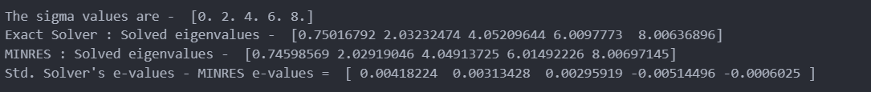

I was surprised to see that the accuracy of eigenvalues increased as I went from sigma = 0 to sigma = 8, whereas the Vi vectors had the exact opposite trend.

In conclusion, looks really good! The algorithm ran really quickly even as I increased maximum iteration count till 10000, with time to execute increasing from 0.6s to 0.7s as I raised max. iterations from 1000 to 10000, suggesting that the actual iterations needed really weren’t that much more to achieve a tolerance of 1e-9. A tolerance of 1e-6 was achievable in <1000 iterations, but >100.